Development opposite school at Bradford Road, Rudloe

The photo below shows ponies (far end) overwintering in the field south of the Bradford Road and west of Skynet Drive at Rudloe. As with the Gladman development at Pickwick, this 12-acre field is threatened with development. The planning application from Hannick Homes is 13/05724/OUT.

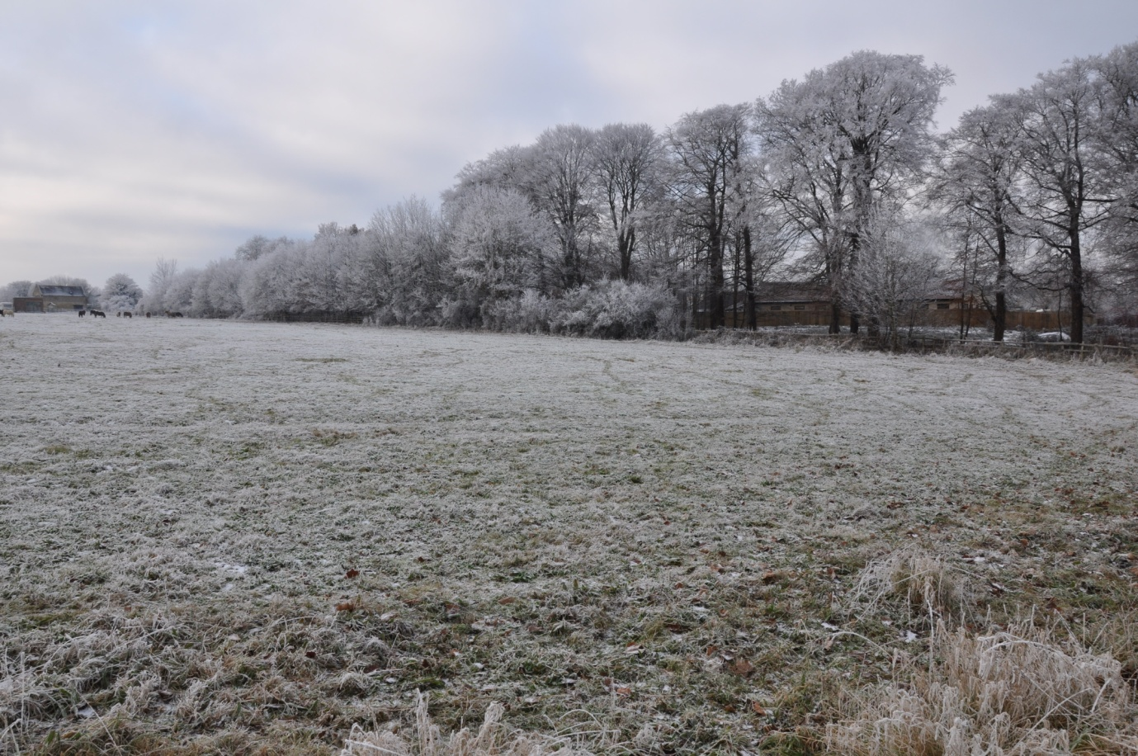

For those people with a computer, in order to view or download the documents, go to: http://planning.wiltshire.gov.uk/Northgate/PlanningExplorer/ApplicationSearch.aspx and enter the application number given above. If you want to try to save this field from development then you must comment before the deadline which is 26th December 2013. You may write to Wiltshire County Council Planning Department at:

Development Management
Wiltshire Council
Monkton Park
Chippenham SN15 1ER

Alternatively, email the Wilts CC’s planners at: developmentmanagement@wiltshire.gov.uk or the case officer, Chris Marsh, at: chris.marsh@wiltshire.gov.uk .

The Rudloe and Pickwick developments will, if allowed to go ahead, swallow up agricultural land equivalent to 21 football pitches. The Rudloe proposal alone includes more than 300 car parking spaces! There are many reasons to oppose the Rudloe development some of which are listed overleaf.
- There is no need to develop greenfield land west of Corsham. The Rudloe/Hawthorn area has an abundance of brownfield sites including Copenacre, Royal Arthur and now the former RAF Rudloe No. 2 Site in Westwells Road which will shortly be released to the market by the MoD. These three sites alone can, and probably will, provide the identified housing requirement (475 homes) for the whole Corsham area to 2026.
- At present, the estates at Rudloe comprise more than 600 homes. The brownfield sites will, sooner or later, be developed. If greenfield development is also allowed then Rudloe will become an enormous sprawling conurbation.
- The fields between Corsham and Rudloe form, what has been called, a ‘strategic gap’. If this Hannick development is allowed at Rudloe (and the Gladman development allowed at Pickwick) then this gap will be reduced and may be further reduced in the future. This would, again, produce an unwanted sprawl resulting in Pickwick (and Corsham and Rudloe) losing their integrity and identity.
- Bath ASU (Aseptic Unit) is currently based at Fiveways Industrial Unit and has outline permission for a substantive expansion into the adjacent field along Park Lane. Its proposal to build commercial units adjacent to Bradford Road is purely speculative.
- Bath ASU is the supposed commercial developer but the planning application is signed on behalf of ‘Masrich Executive Pension Scheme’. Bath ASU have contacted me and confirmed that Masrich Executive Pension Scheme Ltd is in fact the company’s pension scheme.
- The Estates Gazette has almost 150,000 sq ft of commercial property advertised in the Corsham area alone (at Fiveways, Leafield, Pickwick, Spring Park etc). With so much commercial space available, why build more?
- The 600+ homes at Rudloe have no local services. No Spar, no doctor, no dentist, no library, no cafe, no pub, no newsagent, no fish & chip shop, no petrol station and so on. Rudloeites therefore have to travel to access services. This makes them disadvantaged compared with the residents of Corsham, Chippenham or Bath for example. Cars, buses or taxis must be used for every excursion. The cost of the return bus journey to Sainsbury’s for a mother and two fare-paying children is more than £12. This is a sizeable chunk of a budget to lose before shopping even starts. And the developer wants to place 21 more families, presumably on fairly low incomes, into social housing at the proposed development. More families deprived through being isolated from services!
- More than 300 car parking spaces are planned replacing our pictured green field!
- The proposed vehicular entrance to the site, opposite the school and between two blind bends, is not viable in spite of the proposed ‘visibility splay’.
- The road widening scheme will necessitate removal of all the trees opposite the school. There are 41 semi-mature trees (and many shrubs) here that provide a lovely canopy over Bradford Road. See the Rudloe website for photos taken at different times of the year.
- It is reckoned by many that local services (doctors, dentists) will not be able to cope.
- Many people think that local roads are already over-congested particularly at peak periods.

You may keep up-to-date with events at the Rudloe website’s ‘News’, ‘Rudloe’ page here: http://www.rudloescene.co.uk/news-1/rudloe/

Alternatively, for further information contact Paul Turner at wirepuller@hotmail.com or 01225 810408 or 07803 2952891.

