Have you heard about this development?
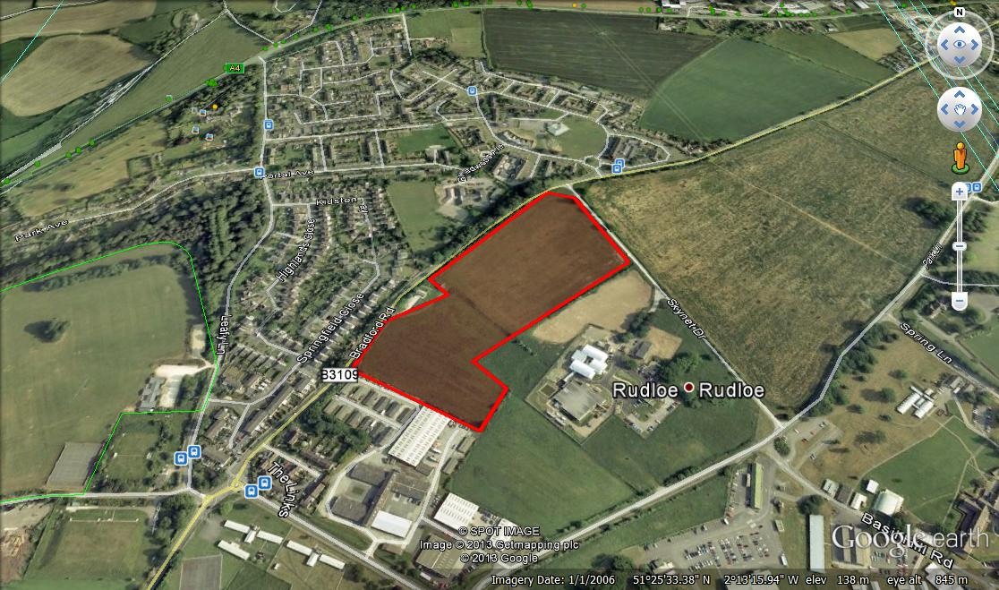
Hannick Homes of Swindon is taking advantage of a loophole in planning law and proposing a 12-acre development at Bradford Road, Rudloe (across from the school – see map above). Their exhibition, which proposed 80+ homes and a large commercial unit, was held at the school on Saturday 22 June. Another similar development is proposed by Gladman Developments in the field opposite St Patrick’s Church (exhibition on 27 June at Corsham Community Centre). Hannick’s exhibition included the statement “The Wiltshire Core Strategy identifies a need for 475 additional dwellings in the Corsham area between 2013 and 2026”. Both of these developments are on greenfield land.

I have objected to our MP (jamesgraymp@parliament.uk), our local councillors (sheila.parker@wiltshire.gov.uk) and (richard.tonge@wilts.gov.uk), Box Parish Council (mailbox@boxparish.org.uk), a number of Wilts CC planners (inc. chris.marsh@wiltshire.gov.uk), with a copy to the developer/agent (homes@hannick.com and info@hunterpage.net) purely on the grounds that the Rudloe/Hawthorn area has a number of brownfield sites already under development or where developments are proposed or possible (the former: explosives factory at Westwells – 34 homes, Royal Arthur site – 221 dwellings, Flamingo Club – 13 homes, Copenacre site – 121 homes, RAF Rudloe No 1 site – 300+ homes possible here given the density of the Copenacre development, and Rudloe Estate ‘Renaissance’ – approx 25 homes. This totals 714 actual/possible homes in the Rudloe/Hawthorn area alone, never mind the rest of the wider Corsham area. So why develop greenfield sites?

Also, a 3-acre office/commercial development is proposed at Bradford Road (another is proposed at Pickwick). My objection here is that there are many vacant units at Pickwick Park, Leafield and Fiveways so why use greenfield to develop more?

There are, of course, many other possible objections to the Bradford Road development including: 1) Local people not outside developers should decide on proposed developments (Wilts CC slogan – “everybody matters”!), 2) There are no services at Rudloe (shops, supermarket, secondary school, doctor, library etc); Rudloe residents are penalised by having to use a car (not good for the environment) or (expensive) public transport; 3) As yet, there are no commercial premises between Fiveways and Pickwick, this area is, effectively, a green belt; this development would start the ‘creep’ that would join Rudloe to Corsham/Pickwick thus creating an unwanted (by locals) conurbation and thereby destroying the individual character of Pickwick and Corsham; 4) Why build a large commercial unit next to new homes? Who would want to buy a home there?; 5) The proposed entrance, opposite the school, is not viable and is unsafe (between two blind bends); 6) Other traffic/congestion issues etc

If local people do not object, then on the planning application, the developer can use this as another reason for development. Please contact me if you would like postal addresses of people to write to regarding this development. You may read my email in the ‘News’ or ‘Rudloe’ sections (menus) of the Rudloe website – www.rudloescene.co.uk or by following the instructions at The Rudloe Mob’s blog here: http://www.litteraction.org.uk/the-rudloe-mob

Paul Turner
29 Springfield Close
Rudloe SN13 0JR

01225 810408 or 07803 295291 or wirepuller@hotmail.com

