Three Men and the Jungle Path – BOX29

The weather was fine, clear blue skies, with brilliant sunshine offering glorious views across the Bybrook valley towards Bath and Colerne.

The three men armed with machetes, bill hooks and saws descended on the overgrown footpath that resembled the Borneo jungle rather than the western edge of the Cotswold Area of Outstanding Natural Beauty (AONB).

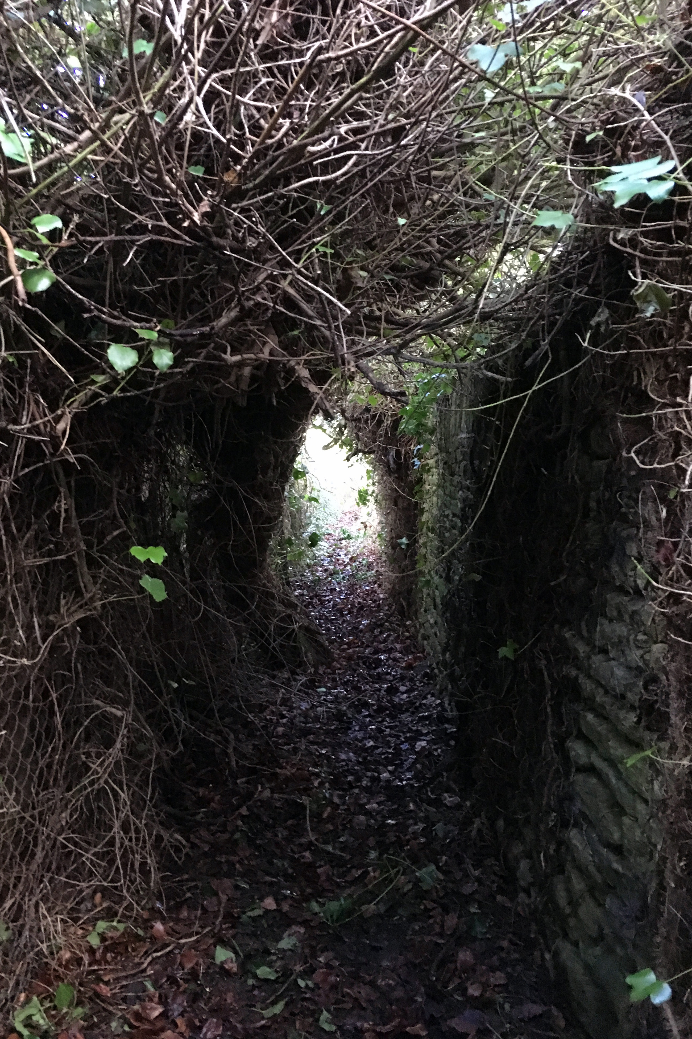
‘The Jungle Path’

Setting to work, the three started to clear the path with vigour and gusto, reducing and removing the trees and brambles that blocked the path in order to improve access to walkers and ramblers.

All three are active and enthusiastic members of Cotswold Voluntary Wardens, Avon Valley District and the jungle path is known locally as BOX29 which is located at the top of Box Hill adjacent to Rudloe Manor and Rudloe Firs.

It is understood that RAF airmen used the footpath extensively when tasked with guarding RAF Rudloe Manor which was the home of 10 Group RAF during the Second World War; the RAF finally closed the gates in 1996.

This year marks the 100th anniversary of the RAF and the 50th anniversary of the Cotswold Voluntary Wardens therefore, it seems appropriate that the heritage of the area should be retained, maintained and if possible improved for future generations.

The Cotswold Wardens were operating in support of Box Parish Council under the direction of Sid Gould, the Cotswold Warden for Box Parish. The weekly workout offered by the Work Party schedule can be challenging, but the health benefits provide a considerable incentive.

BOX29 path clearance is one example of the work undertaken by the Avon District Voluntary Wardens. Working Parties can often be seen working in our area repairing and restoring dry stonewalls, maintaining the labyrinth of paths and by-ways, coppicing woodland and planting trees.

Meanwhile, monthly-guided walks are lead by the Wardens such as the Tuesday Tramp out of Colerne.

The Cotswold Voluntary Wardens are keen to recruit new members to continue this valuable work. For more information please take a look at the Cotswolds Area of Outstanding Natural Beauty website at www.cotswoldsaonb.org.uk/looking-after/volunteering

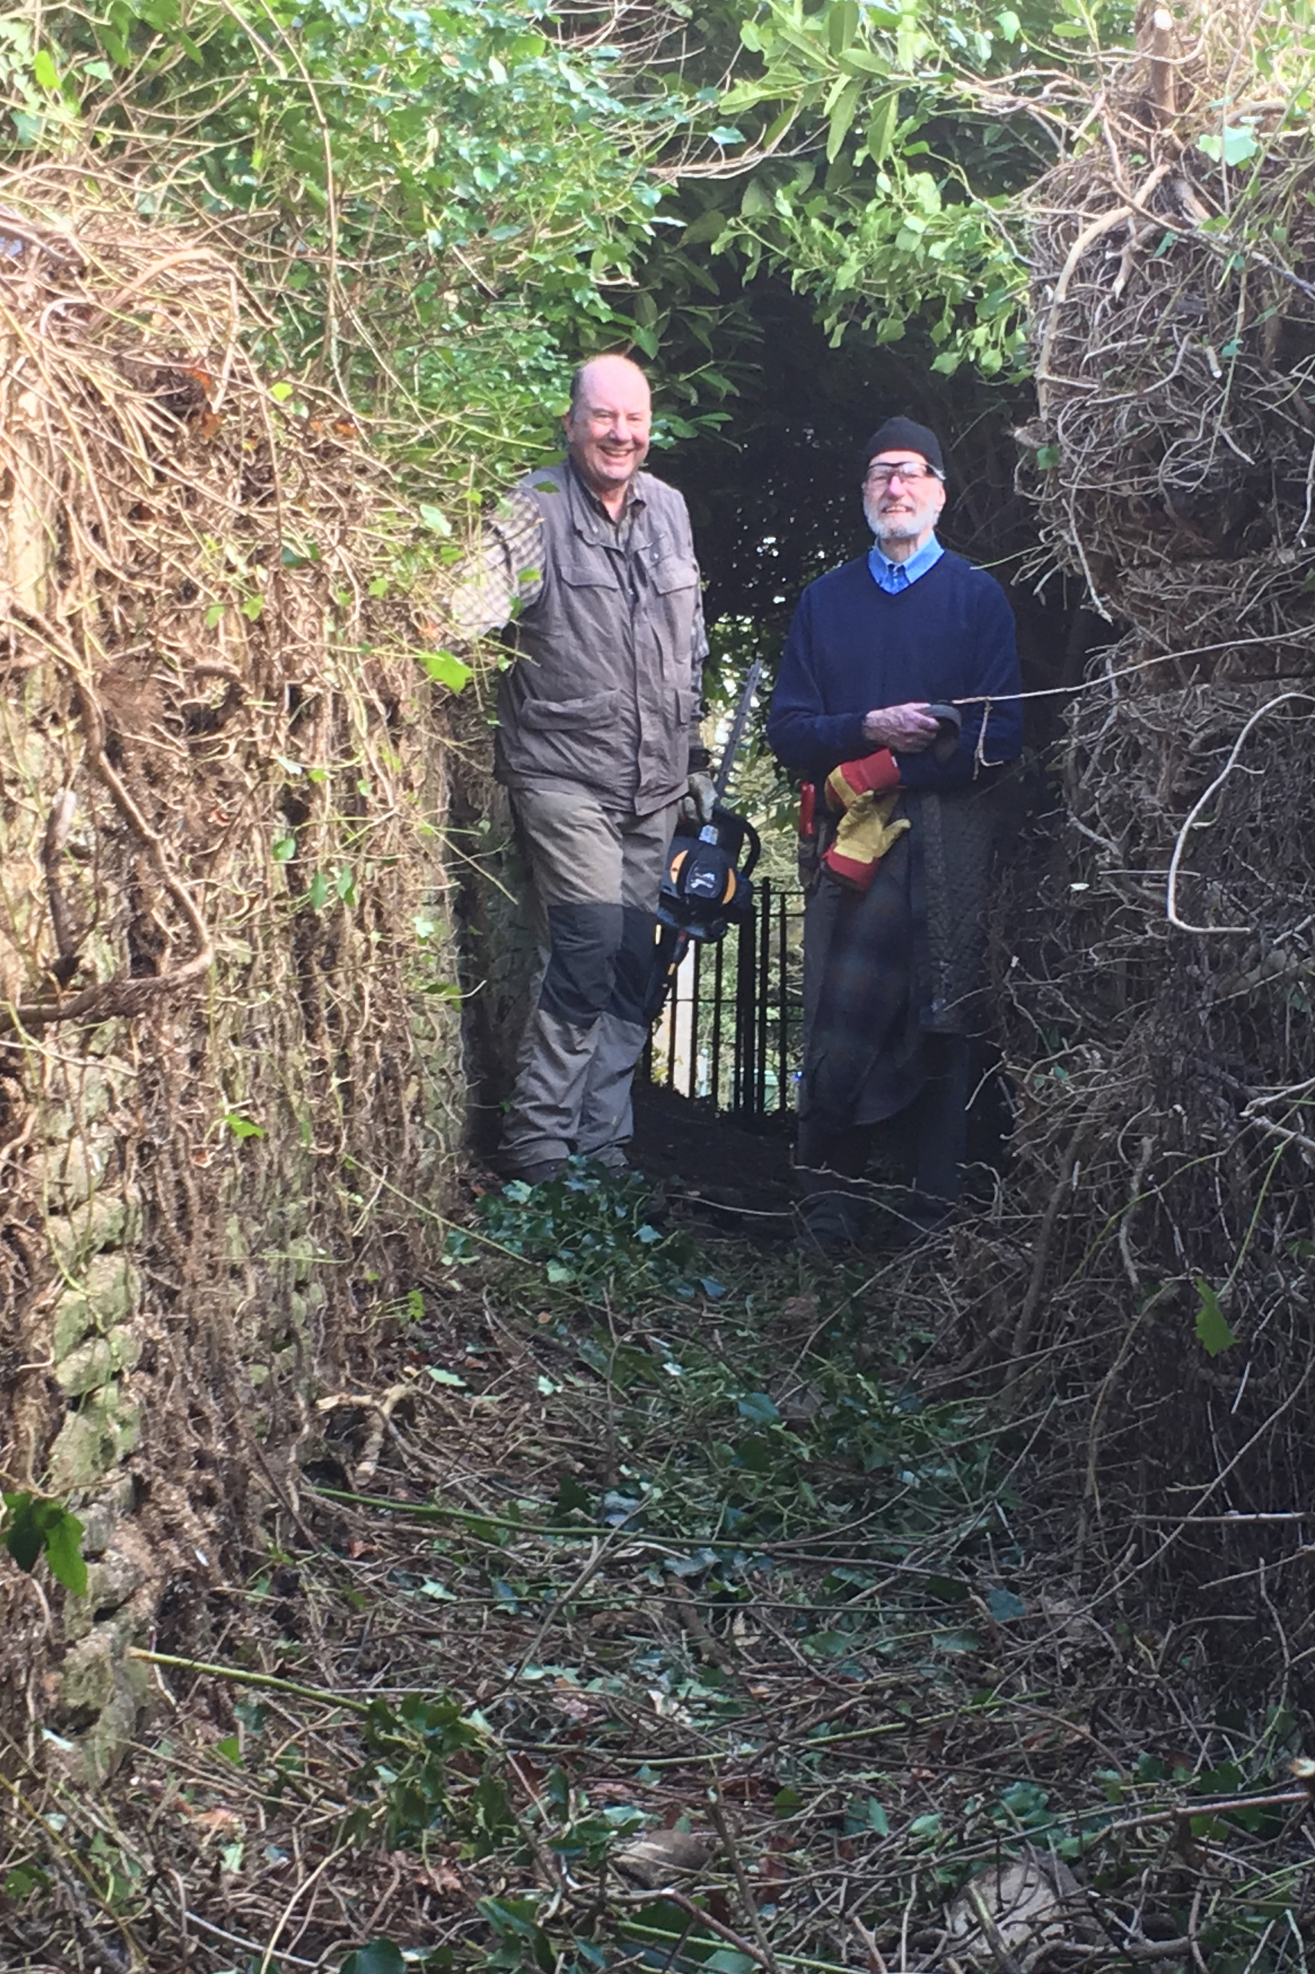
The Clearing Crew
David Wright
Avon District Cotswold Warden

