STATEMENT TO THE WILTSHIRE NORTHERN AREA PLANNING COMMITTEE
ON 16/03721/REM & 16/04544REM ON 6TH SEPTEMBER 2017

My name is Nigel Jackson and I live in Chestnut Grange in Corsham. I wish to give you a clear view of a layout matter which is a very serious health and safety and highways risk which has been raised in formal comments on the planning applications in our letters in June 2016 and July 2017. This risk is from damage to the above-ground gas installation that is opposite the proposed estate road exit and which is very close to the A4 pavements and Nos 10, 11 and 12 Chestnut Grange.
This gas installation is not hardened or protected against any form of impact and is vulnerable now. The increased risk of accidents at the new road junction and the risk of vehicles shunting into this vulnerable installation is a significant threat to pedestrians, road users and residents. A major rupture of this system, the unintended release of pressurised gas and the possibility of a fire should be carefully assessed.
Wales & West Utilities Ltd own the installation and they were unaware of the implications of the estate plans. At my urgent instigation, their Network Support Officer agreed on 8th August to investigate the probabilities of an incident and to discuss it with the developers and their own health and safety representatives. Wales and West Utilities planned to respond to me by 18th August. On my prompt on 23rd August they told me they would chase it up. I asked again on 1st September. I have not received any response and I assume that the serious implications of the risk, multi-agency responsibility for the risk and its commercial impact are unresolved.
Councillors will understand our concern. There have been two serious road accidents on our stretch of the A4, one destroying part of the drystone wall and another causing serious structural damage to a building. The higher probability of an accident at the new estate road junction, close to the gas installation, cannot be dismissed.
Speaking for all residents, we feel that we have raised our concerns formally, responsibly and early in the planning process, but our advice has been disregarded. Overlooking the risk to the gas installation and all people near it is an oversight that flies in the face of the Council’s duty of care to its residents.
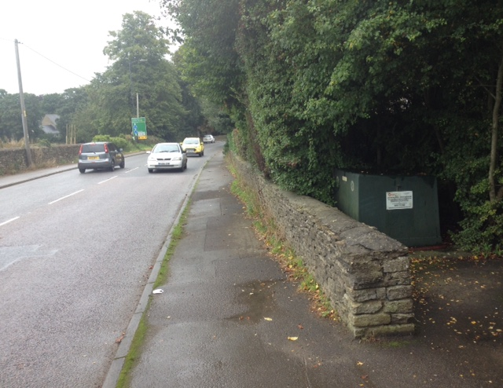
(I can provide you with photographs and written evidence).

