Community right to bid for assets of community value
(Note that each item below is taken from the online nomination form. However, as there is so much to say about the land to be nominated, a comprehensive report was considered necessary)
1. Area to be covered
“Please describe the nominated land including its proposed boundaries and exact location, address, postcode and a map attachment if possible”
A major part of Leafy Lane Wood, Leafy Lane, Rudloe in the parish of Box
An aerial map of Rudloe with a fairly accurate approximation of the part of the wood being offered for sale is given at appendix 1.
2. Ownership
“Please state all the information you have on the names of current occupants of the land, and the names and current or last known addresses of all those holding a freehold or leasehold estate in the land. Please include a copy of the land registry entry where possible”.
Leafy Lane Playing Fields Ltd (LLPF), a registered charity, is the current owner of the freehold, the land having been purchased from Mr Graham Padfield of Park Farm, Kelston through Lottery, local authority and other grants in 1996. LLPF’s Certificate of Incorporation, obtained from Companies House, is attached. The chairman of LLPF is Mr Stevenne Bray of 27 Highlands Close, Rudloe, Corsham SN13 0LA.
With regard to the charitable status of Leafy Lane Playing Fields, the local community has questioned the Charity Commission regarding LLPF’s ‘right’ to sell the woodland. This is in view of the stated aims of LLPF, in their 1996 Certificate of Incorporation (as a limited company) and through a 1997 extraordinary general meeting: 'To advance and improve the education and physical, mental and social well-being of the community by the provision of sporting and recreation amenities, grounds and facilities of all kinds' and ‘To provide for the inhabitants of Corsham and surrounding areas in the interests of social welfare facilities for recreation and leisure time occupation with the object of improving their conditions of life'.
Disappointingly, the Charity Commission has ruled that LLPF does have the ‘right’ to sell the woodland providing certain conditions are met. These conditions are that: ‘decisions are reached in accordance with (1) the requirements of the charity's governing document, (2) at quorate trustee or membership meetings by the required majority vote’ and (ref. section 121 of the 2011 Charities Act) ‘that public notice be given (3) in the area prior to a decision on disposing of land and that trustees consider any objections received during the notice period’. With regard to (1), this decision does not appear to be in accordance with the charity’s governing document and (2) it is not known if the decision was made through a quorate meeting by majority vote as LLPF’s meeting minutes are not published and (3) no consultation took place with either the local community or Box Parish Council about the decision to sell.
This places the local community in an invidious position as it was thought that LLPF’s stated charitable aims would continue throughout the life of the charity. The local community now feels it has to ‘jump in’ to save the woodland from potential buyers who may not have community aims at heart. Ironically, the community’s aims would effectively be the same as those of LLPF in 1996 vis (and I paraphrase their documents): ‘Advancing and improving the education and physical, mental and social well-being of the community by the provision of recreation amenities’ and ‘To provide for the inhabitants of Rudloe in the interests of social welfare facilities for recreation and leisure time occupation with the object of improving their conditions of life'.
3. Community value
“Your reasons for thinking that Wiltshire Council should conclude that the land is of ‘community value’, having regard to the definition in the Localism Act including:
a. the current primary use of the building/land or use of the building/ land in the recent past furthers the social well-being or social interests (cultural, recreational, or sporting interests) of the local community
b. is it realistic to think that now or in the next five years there could continue to be primary use of the building/land which will further the social well-being or social interests of the local community (whether or not in the same way as before)”
The age of Leafy lane Wood is not known precisely but some assumptions can be made based on elements of the woodland which are of local, historic value. The wood contains a lime avenue which forms a junction with Leafy Lane and ‘points to’ what is now known as the Rudloe Arms (formerly Rudloe Hall Hotel and Rudloe Park Hotel but originally Rudloe Towers). Rudloe Towers (now grade II listed) was built in 1875, by J Hicks of Redruth, for the Pictor family who were local quarry owners. The Pictors wished to emulate the Corsham Methuens by building a grand house 'above' Corsham and this included a lime avenue leading to the house, emulating those at Corsham Court. In the days of the carriage and turnpike trusts, this lime avenue would have led from the London-Bath turnpike road at what is now Rudloe Fiveways to Rudloe Towers. The lime avenue and its surrounding woodland (now Leafy Lane Wood) provided a wooded ‘tunnel’ from which family and guests would emerge at the Towers with its magnificent panoramic views over the By Brook Valley.
As well as the lime avenue, the approximately five-acre part of the woodland which is being offered for sale (perhaps another two or three acres, principally bordering Leafy Lane, is proposed to be retained by LLPF), contains much flora and fauna of value (certainly to local people). Indeed, Mrs Wooster who lived at Rudloe House opposite the wood and walked in the woodland on most days, compiled lists of Leafy Lane Wood flora and fauna between 1982 and 1994 – the lists are attached as appendices 3 through 7 (with an addendum at appendix 8) but can also be found online at the Rudloe community website here: http://www.rudloescene.co.uk/localities/rudloe/leafy-lane-flora-fauna/
At the time of the woodland’s transfer from private hands (Mr Padfield ) to charity/community ownership (LLPF) in 1996, a comprehensive survey of the woodland was undertaken by Greenman Environmental Management of Bath. The local copy of this report has been lost but Greenman has promised to search their archives for the original and forward a copy. In 1995, through the auspices of the local Rudloe Action Group, a blanket tree preservation order (TPO) was established for the wood and other trees on the playing fields. The details of this TPO including the schedules of trees covered may be seen on the Rudloe community website at the ‘link’ given above and also here: http://www.rudloescene.co.uk/news/rudloe/leafy-lane/.
The wood has been used extensively by local people since the building of the Rudloe estates from the early 1960s onwards. This usage has included simple recreational walking which would include enjoyment of the flora and fauna (ref Mrs Wooster’s lists), dog walking (see next paragraphs), children playing (see next paragraphs), more ‘organised’ children’s activities (we held a treasure hunt in the wood in September 1994 as part of our son’s seventh birthday celebration) and so on. The wood is criss-crossed by many informal footpaths which have been used continuously, as indicated above, at least since the 1960s. The paths are not shown on the ‘definitive’, Wiltshire Council map of footpaths, bridleways and byways but are de facto paths which could be formalized through the Wiltshire Council procedure by their established use. An aerial map, with the wood highlighted and the approximate routes of the pathways is given at appendix 2. From the western end of the woodland, a footpath continues to Boxfields Road thus giving a through route from Leafy Lane. Indeed, this route was separated from the main playing field area, by LLPF, in 1996 or thereabouts, by the planting of a mixed hedge of field maple, hawthorn, dogwood, blackthorn and rosa rugosa.
When we had our dogs, over a period of about 26 years from 1979 to 2005, walks invariably began in Leafy Lane Wood. Many friends and acquaintances from other parts of Rudloe were not only encountered here but friendships were ‘made’ and cemented here whilst walking with dogs. In my approximately five-minute wait for the 9 o’clock Bath bus each Wednesday, I usually see entering the wood: a young lady with small child and dog, a young lady with two dogs and a couple with two dogs. On 17th May 2015, for the purpose of confirming the pathways in the wood, I undertook a, perhaps one-hour, photo-shoot in the wood. In this time, I encountered (and either passed the time of day with or stopped to chat with) a ‘military’ man with young puppy (chat), a grandfather with grandson and dog (time-of-day), a ‘military’ couple with child in buggy and dog (time-of-day), a grandfather with grandson and two dogs (chat with both grandfather and grandson about the flora and other things – the child was most interested in ‘cow parsley’ and ‘yellow archangel’) and a young man with small dog (time-of-day). I trust that these examples illustrate the importance of this wood in the social fabric of Rudloe.
With regard to children playing, the ‘art’ of unsupervised, informal play is largely being lost in our modern, formalized, supervised world. The only other area of ‘natural’ woodland at Rudloe was, in 2012, lost to formalization when the woodland between Corsham Primary’s Broadwood site and the Bradford Road was gifted by the GreenSquare organization to the school and thereby lost to informal play. The school’s July 2012 newsletter stated: “Over the summer, we aim to fence and clear the area in order that we can establish Corsham Primary’s own Forest School in the autumn term. Children from both sites will be able to use this lovely new facility”. Fine, except that the woodland was lost to informal play and lost to local children during summer evenings and long summer holidays. Until 2012, dens could always be found in this woodland but now it is lost to Rudloe’s children. So we come to Leafy Lane Wood, the one remaining piece of woodland in Rudloe. Thankfully, children can and do play here as kids have done for generations – please see the photo at appendix 9, taken during the 17th May 2015 walkabout, of a well-constructed den in the wood.
An indication of the importance of the woodland to the local community is illustrated on the Rudloe community website where the woodland features in numerous photographs and articles, for example:
In the 16th April 2015 and 9th May 2015 articles here: http://www.rudloescene.co.uk/news/rudloe/
As indicated above, in TPO articles here: http://www.rudloescene.co.uk/news/rudloe/leafy-lane/ and again here: http://www.rudloescene.co.uk/localities/rudloe/leafy-lane-flora-fauna/
In photos 28, 29, 30, 31 and 33 of the 3rd May 2015 gallery and in photos 1 to 6 of the 23rd November 2014 gallery and in photos 1 to 10 of the April/May 2014 gallery and in photos 1 to 11 , 21, 24, 37 to 40, 45 to 48, 55 to 61, 70, 75, 76, 88 to 91, 97, 98, 100 (showing kids trooping across to the wood in 1979), 120, 127 and 128 (showing a scarlet elf cup which is not included in the flora lists) in the Views of Rudloe including Leafy Lane Wood gallery here: http://www.rudloescene.co.uk/localities/rudloe/ and in the individual photo ‘winter aconites in Leafy Lane’ at the same location.
And in the ‘title’ photo of the Box Hill webpage here (if one photo is worth looking at it’s this one!): http://www.rudloescene.co.uk/localities/box-hill/
4. Eligibility to nominate
“Please provide evidence that you meet the definition of a community nominator as set out in the regulations (i.e. a parish council or voluntary or community body with a local connection). If an unincorporated group please provide a list of 21 names on the local electoral register”
See 5. Below.
5. Your details
Parish | Box
Community area | Rudloe
Your organisation | Springfield and Clift Close Residents Association
Contact name | Paul Turner
Position held | Committee member
Address | 29 Springfield Close  Rudloe  Corsham
Postcode | SN13 0JR
Telephone | 01225 810408
Email | wirepuller@hotmail.com

I confirm that all information provided is accurate and complete

Name | Paul Turner
Signature | Paul Turner
Date | 18th May 2015

Appendix 1 – map highlighting the part of Leafy Lane Wood being offered for sale and its Rudloe environs
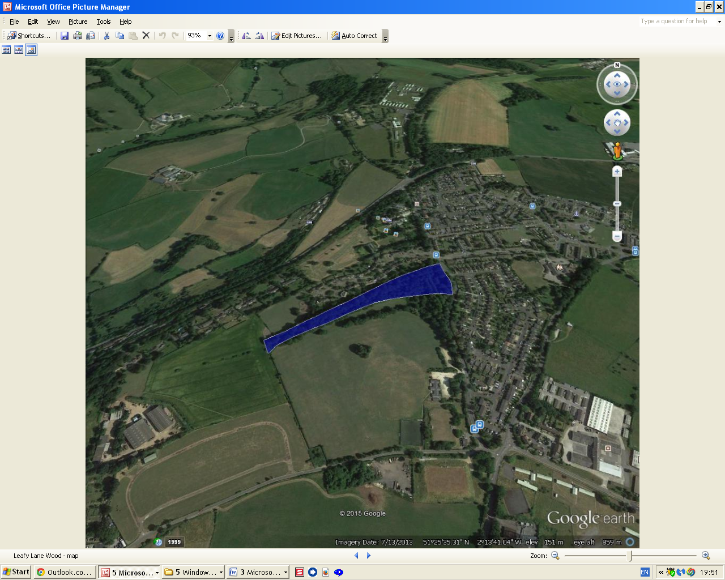

(note that this is just a ‘screenshot’ of file contents; a copy of the original file will be enclosed along with this ‘right to bid’ document)

Appendix 2 – map showing the extensive footpath network within Leafy Lane Wood
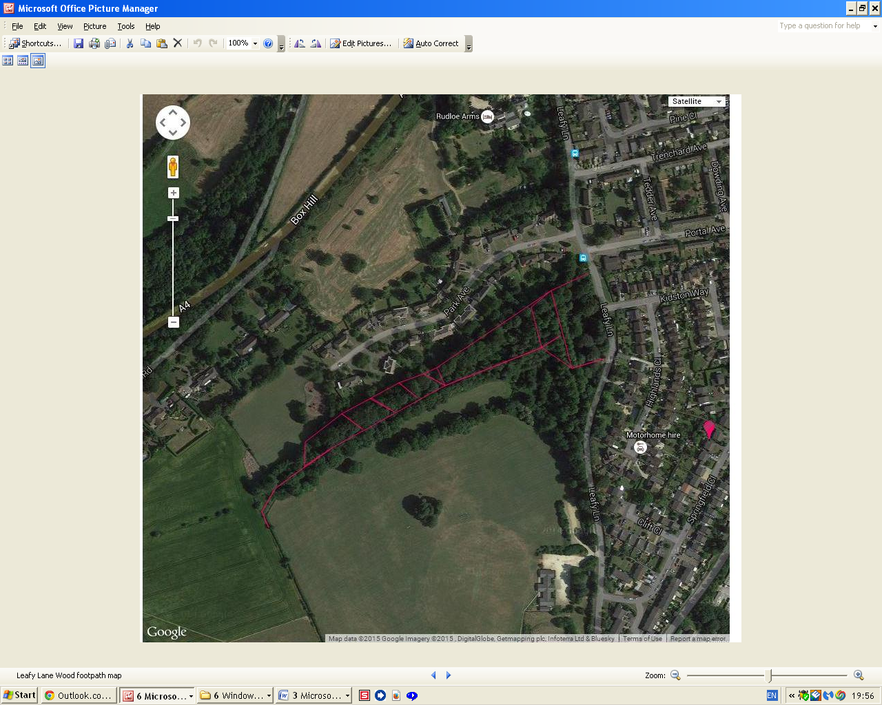

(note that this is just a ‘screenshot’ of file contents; a copy of the original file will be enclosed along with this ‘right to bid’ document)

Appendices 3 - 7 follow – Mrs Wooster’s flora and fauna lists (1982 – 1994)
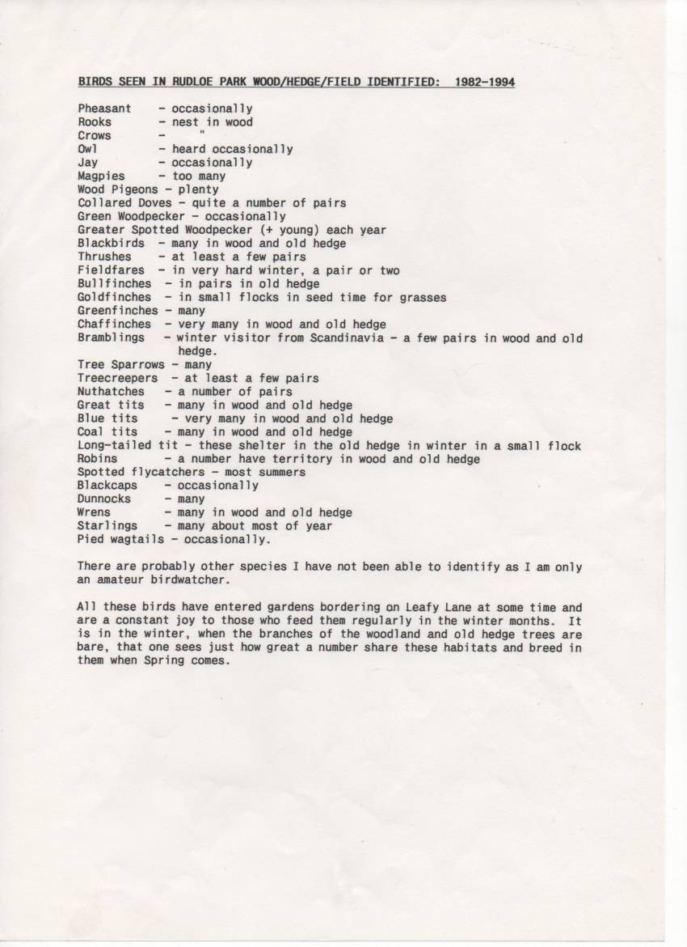
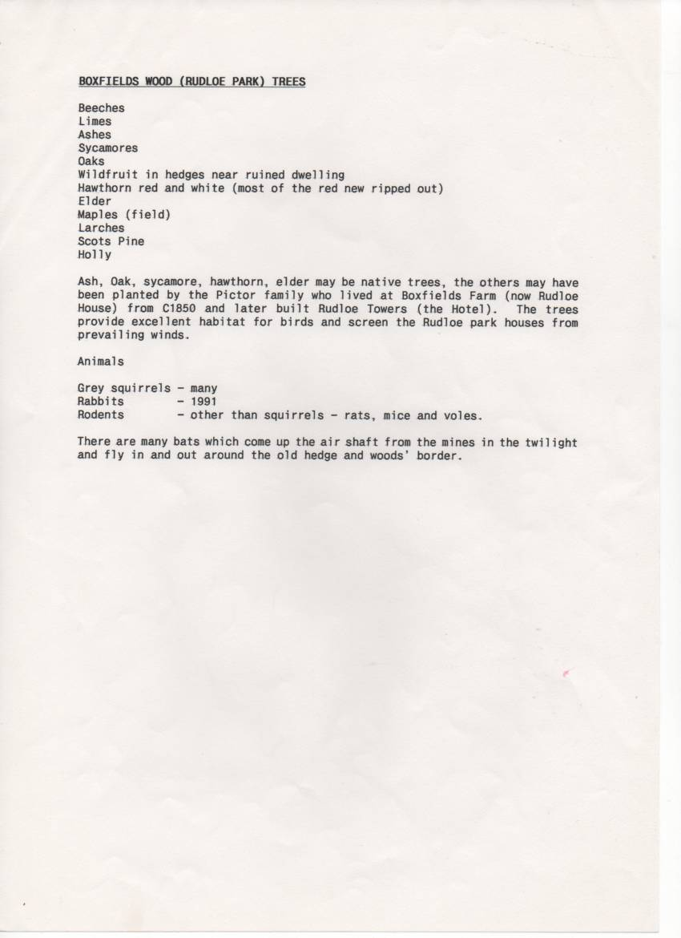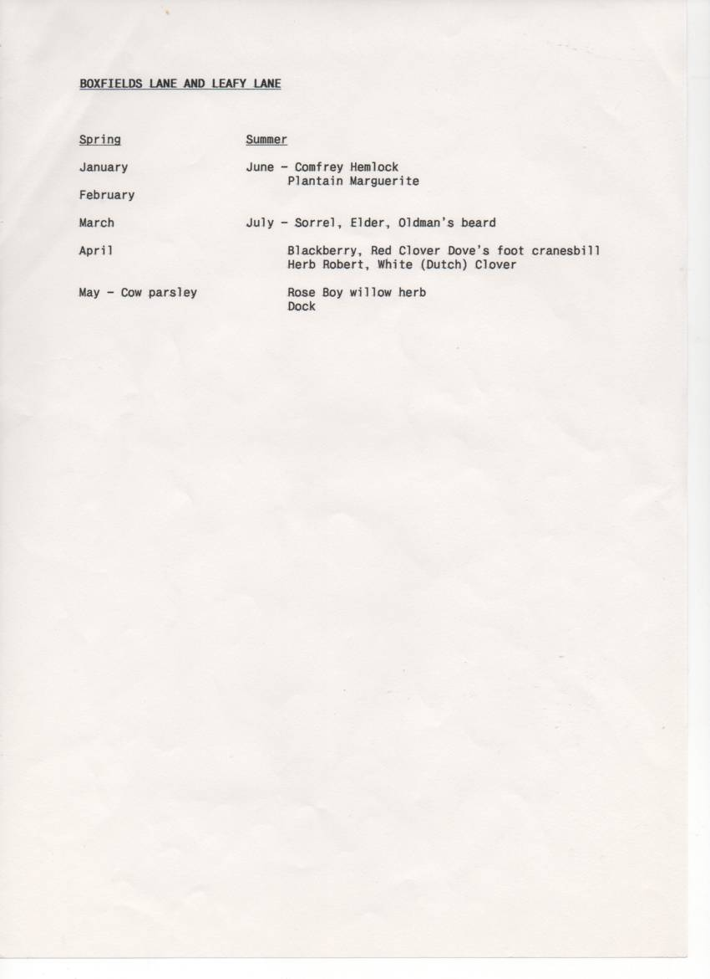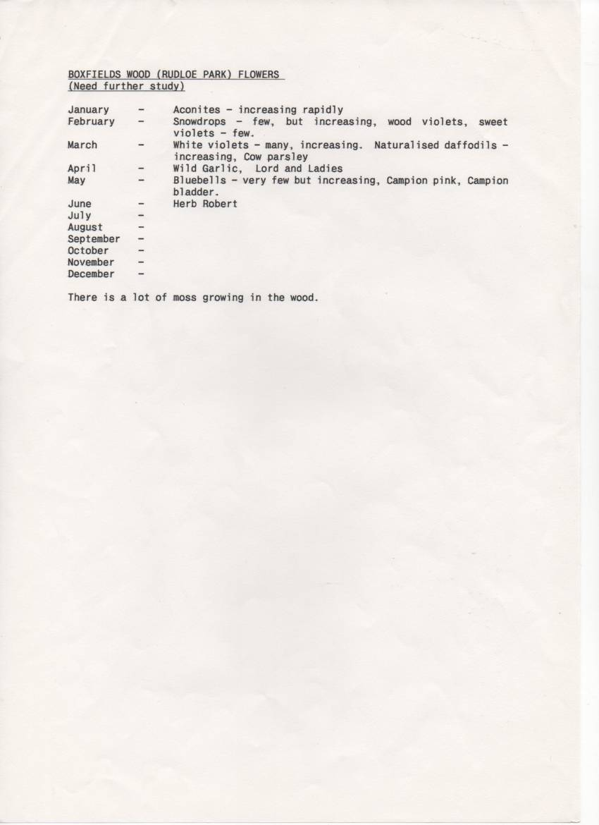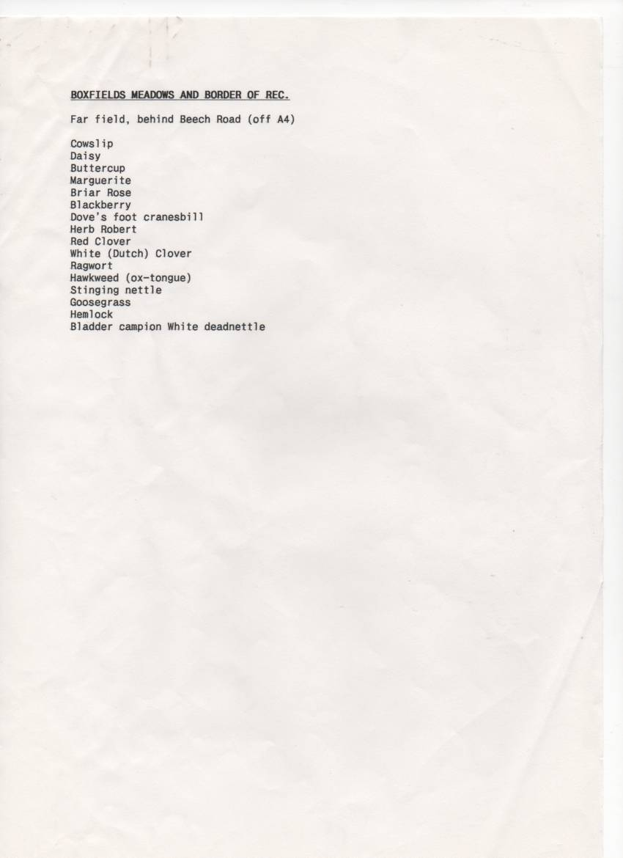
Appendix 8 – addendum to Mrs Wooster’s flora and fauna lists
Flora and Fauna in Leafy Lane Wood
Whilst Mrs Wooster’s flora/fauna list of 1994 is comprehensive, it is not exhaustive. She does not mention:
Trees
- The two hornbeams at the western edge of the wood (opposite the former NAAFI & HIVE)
- The two whitebeams in the line of trees that divides the main playing field area and the small meadow
Plants
(the first three in this list she may not have mentioned as they are quite rampant ‘weeds’). The first five are prolific in or around the wood.
- Nettle
- Dog’s mercury
- Wood avens (aka herb bennet)
- Celandine
- Garlic mustard
- Ground ivy
- Star of Bethlehem (I have not seen this but Marg Harvey and Gwen Davies of 4 Springfield Close regularly walked through the wood with their different dogs over the years and told me that they had seen this on a number of occasions)
It is ironic that Mrs Wooster mentions that bluebells and aconites are increasing in 1994 as by 2008 or thereabouts the bluebells had ‘disappeared’ and the aconites have reduced markedly. This reduction is, I believe, a result of people unwittingly dumping their garden rubbish into the woodland without any thought of what wild plants they might be covering. To some degree, this appears to be the case even with the applicant undertaking the tree works ref 09/00482 in 2009/10 as some of the many branches pruned from the trees alongside Leafy Lane (this work is not mentioned in 09/00482 by the way) have been laid on top of a patch of aconites.
Birds
Buzzards are on the increase and they are frequently seen either soaring high on thermals or in and around the woodland. As there is a large rookery in the wood (nesting no doubt disturbed by recent (March 2010) chainsaw activity) rooks can often be seen harassing a buzzard.

Appendix 9 – a well-constructed den in Leafy Lane Wood

