Dear Chris & Development Management North,
Planning Application 14/04484/FUL
Construction of 8 dwellings and parking spaces at Long Close Avenue, Rudloe

This proposal, which was formerly described as Rudloe Renaissance’, is founded on a fabrication i.e. that feedback from residents had identified garage areas as underused spaces that were dumping grounds for waste and attracted vandalism; an examination of this state of affairs is shown immediately below and is largely taken (with some modification) from the article ‘19th February 2014 - Rudloe development’ on the Rudloe website here: http://www.rudloescene.co.uk/news/rudloe/

“In March 2013, Wiltshire County Council published its 14-page Rudloe Housing Needs Survey. The survey’s findings were based on questionnaires delivered to every one of the 565 households in Rudloe. Just 30% of the questionnaires were completed and returned.

The conclusion/recommendation of this survey was that ten new subsidised homes and one new sheltered home were needed in Rudloe over the next three years.

In 2013, the housing association GreenSquare conducted its own consultations with Rudloe residents on the subject of Rudloe Estate development. In May 2013, its Rudloe Update stated that “residents had identified the garage areas as underused spaces that were dumping grounds for waste and attracted vandalism” and “this feedback was our starting point for considering redevelopment”.

These statements were presented without evidence. Indeed, local residents have told me that there is no such problem. For example, two residents (names supplied on request) who have lived in houses backing onto the garages for 40 and 50 years have said that the only incidents over all this time had been the odd vehicle ‘dumped’ there – owners could, however, always be traced through a vehicle’s number plate. It appears then that GreenSquare’s “starting point” has been contrived.

“Garages underused”? Given the £44 per month rental, it's hardly surprising that residents have chosen to park their vehicles in the roadways. With the impending demolition of garages with just three weeks' notice (which GreenSquare describes as “making things easier”) after 50 years of occupation, Rudloe Estate’s roadways will be more congested and more difficult to negotiate.

The occupants of houses in Northcroft Road, Prestley Wood Road and Leylands Road have been able to park their vehicles in and around the garages at the rear of their properties for those fifty years. However garage sites, including forecourts and access roads, are GreenSquare property and GreenSquare has informed me that there is no extant permission for any parking in the garage areas. See the result of removing a vehicle from its usual parking spot in the garage area to the only available option, the roadway in front of a Leylands Road house, in the picture below. Buses, emergency vehicles, delivery trucks etc are finding it difficult to negotiate the roadways.

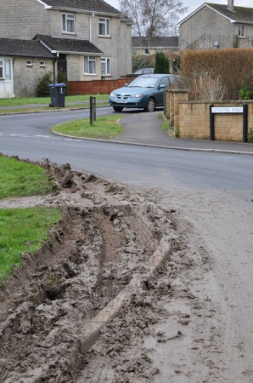

Increasing density and expansion are becoming endemic to west Corsham: the West Point development at Westwells – 39 homes, ‘Wadswick Green’ at the former Royal Arthur site – 221 homes, the approved Hannick development in Bradford Road – 88 homes, Copenacre – 94 homes, RAF Rudloe No 2 Site – 200 homes, the speculative Gladman development at Pickwick – 150 homes, the speculative Redcliffe development in Bradford Road – 170 homes. Excluding West Point and Wadswick Green, most, if not all, of these developments will include a ‘40% social housing’ requirement – so, 280 social homes in west Corsham if all developments are approved. And GreenSquare wants to increase the housing density of Rudloe Estate through demolishing garages and building social housing!

The Hannick development of 88 houses just across the B3109 from Rudloe Estate, includes about 200 parking spaces. So, on one side of the B3109 we have a development with ample parking and on the other side a development drastically reducing parking for existing residents whilst providing parking for its proposed new houses.

Sixty years ago, the Rudloe/Boxfields prefab estates had a school, community centre, doctor’s surgery, library, grocer, butcher, fish & chip shop, cobbler and coal merchant. Now, for the 565-home Rudloe estates, just the school, the "not fit for purpose" community centre and a small, very limited convenience store remain. Rudloe does not need or want increased density or greenfield development – it needs and wants services. The approved Hannick development and the brownfield developments at Copenacre and RAF Rudloe No 2 Site with a total of 382 dwellings will more than satisfy the identified housing requirement for the west Corsham area.”
The photographs below indicate the type of parking problems, similar to those in such areas as Woodlands Road in Chippenham, that will result with the loss of parking spaces at Rudloe. Fifty years ago, Wilts County Council anticipated future private vehicle ownership by incorporating ample garages and parking spaces in its planning of Rudloe Estate. Similarly, GreenSquare continues this ethic by including two parking spaces for each of its proposed homes. However, these spaces are provided at the expense of existing residents through the demolition of garages and the denial of parking space at the rear of homes.

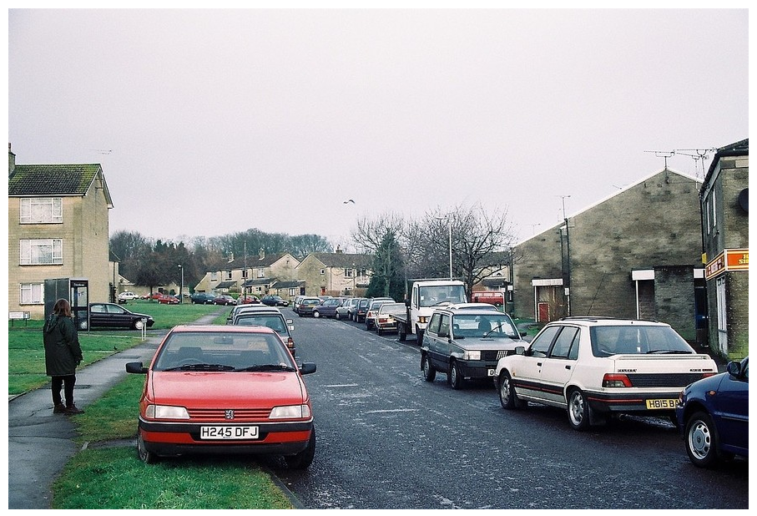
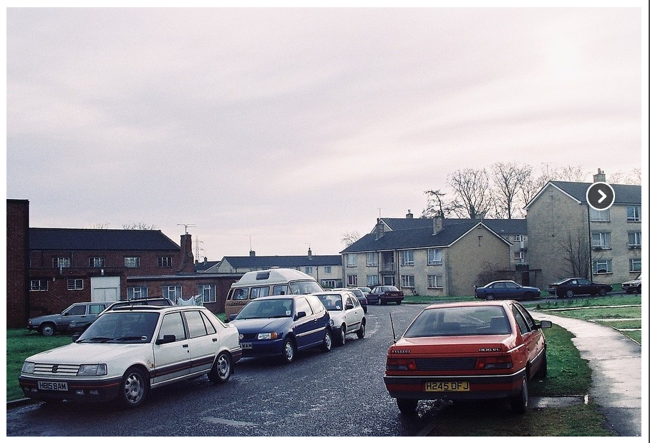

In other missives, I have indicated that a previous ‘renaissance’, that of the new Rudloe Community Centre, has been a planning, financial and community disaster. Likewise, the subject proposal does not leave me with a warm feeling.

Paul Turner
29 Springfield Close
Rudloe

2nd June 2014

