Dear Mr Staincliffe and Development Management,

Planning Application 14/04179/OUT – Land at Bradford Road, Corsham
Development of up to 170 dwellings etc by Redcliffe Homes
1. Regarding our recent email exchange (Mr Staincliffe), thanks for the clarification. I appreciate that decisions on planning applications are taken based on the Local Plan, Core Strategy and the NPPF but you, the planners, are the experts in this field and so should be able to determine whether proposals such as 04179 accord with these plans and strategies. I do not propose therefore to negotiate this minefield within which it seems possible to argue either way or both ways. Mr Musson, in his objection letter dated 26th May appears to put the case against this application well enough with regards to the Local Plan(s) and the emerging Core Strategy so I second his objections in these respects.

3. It should however be possible to argue against the case put by the developer (shouldn’t it?) particularly when that case is full of holes and misinformation. I therefore base my objection below on the analysis and rectification of the inaccuracies in this planning application’s supporting documents.

a. The Design and Access Statement by BBA Architects dated April 2014

i. In its Introduction states: "The site analysis indicated the need to create a landscaped transition between the built edge of Corsham and the countryside. The scheme aims to provide a low density development that addresses the road frontage set in a strong and dense landscape. The development sets out to provide a green edge in the transition from countryside to Corsham". My response: Firstly, this statement is irrational, preposterous even. The existing 20-hectare 'green' field already provides the so-called "green edge" to those entering Corsham from the south-west along the B3109. Any development here would effectively link the existing Corsham/Pickwick boundary with the already-approved development by Hannick at Rudloe (13/05724/OUT), the Fiveways Trading Estate and the impending 200-dwelling development on the former RAF Rudloe No 2 Site (a planning application for this brownfield site is proposed by year-end through Belgrave and its consultant, Framptons). So Corsham will, through this proposal, start not where the recent town sign has been located but 1.3km further west at around the communications tower close to Rudloe Fiveways. Arthur Mee's postwar 'Wiltshire' describes Corsham thus: "It lies unspoiled a little way off the road from Bath to Chippenham, with a long street of quaint houses ...". This proposal, along with the other current greenfield speculations in west Corsham will turn our unspoiled town into a damned great conurbation.

ii. Part 2.2 'Accessibilty and Facilities' states: "The town centre is thriving, whereas many others, such as Melksham, are struggling". My response: Clearly BBA has fallen way short with its research. Corsham has one small supermarket - the Co-op; Melksham has five - the Sainsbury's and ASDA superstores, Waitrose, Aldi and Lidl. If this state of affairs supposes some kind of benchmark for development, then build in Melksham, not in Corsham.

iii. Part 3.2 'Suburban Development' contains many inaccuracies. Even with my relatively superficial knowledge, the following errors have been found in this part. This does not bode well for the overall veracity of this document (and probably other supporting documents too):
- Prospect was built by Smith & Lacy (not Lacey)
- Katherine Park was completed in 2006, not 2010
- Rudloe was developed in the 1960s and 70s, not '1970s-1990s'
I would say that this is typical of 'outsiders' making superficial statements and superficial judgments regarding local issues. As stated at the outset of the current government's term of office (but which has been largely flouted), local people should be making the decisions about local developments.

iv. a. Part 5 is BBA's fantasy - its so-called Outline Development Design Approach. This contains the customary "sustainability", "sense of place", "open space", "landscaping" with "tree-lined avenue", "children's play area", "access points", "on-plot parking" and so on. In other words, all the usual, trite, hackneyed stuff that all such developers have lined up for their 21st-century speculations. A mutation here though has gratuitously thrown a medical/community centre into the mix. Never mind that millions have just been spent on the new Corsham Community Campus less than a mile away or that the £1,000,000 Rudloe Community Centre, built in 2000, lies largely unused and "not fit for purpose" (Wilts CC description) just over a half-mile away.

iv. b. And, unaccountably, the "visually impaired" receive special attention here with: "Lighting and materials will be used to create locally lit areas to help the visually impaired." and "... hard and soft landscaping to allow the visually impaired better access through the site". I would imagine that this text has been copy/pasted from a development proposal for the disabled, otherwise why give special attention to this particular disability?

iv. c. What on earth does this mean ... "The scheme will support the local biodiversity by maintaining the existing landscaping, where possible. New landscaping will also encourage and enhance the biodiversity of the area". How can the building of 170 homes maintain the existing landscaping? And how can it encourage local biodiversity? Just as a matter of interest, the miscanthus field provides habitat for a local population of muntjac which are not native or protected (see, or rather listen to, the 30th December 2013 recording of muntjac 'barking' in this field here: http://www.rudloescene.co.uk/localities/rudloe/) but add to the ‘biodiversity’.

iv. d. "New access points will give the opportunity for easier pedestrian crossing access". What neither this proposal nor the previous 'granted' Hannick application (13/05724/OUT) further along Bradford Road makes clear is that developments between Park Lane and Bradford Road are 'islands' with no direct access to footpath or cycle routes into Corsham (or Rudloe/Hawthorn). The Bradford Road footpath and the Park Lane cycleway/footpath are on the north side and south side of their respective roads. Every walking or cycling journey from/to this estate will require the crossing of these busy roads.

iv. e. Part 5 goes into all sorts of fussy detail regarding casement and bay windows, quoins, coloured render, cornicing etc but fails to mention the most fundamental aspect of a home - its internal (and external) space. Britain builds the smallest homes in Europe (described in a recent press articles as "shoebox homes"); in Ireland, new homes are, on average, 87.7 sq m (15% bigger), in the Netherlands, 115.5 sq m (53% bigger) and in Denmark, new homes are 137 sq m (80% bigger). So, less of the insignificant detail please and let us have the proposed space specifications to see how they compare with our continental neighbours.

b. The Ecological Appraisal by Engain dated 15 April 2014

i. Section 1.1 of this report states: "Engain was requested by Redcliffe Homes to undertake an extended ecological appraisal, hedgerow survey and protected species surveys for bats, dormice and badgers at an application site adjacent to Bradford Road, Corsham, Wiltshire. The site is being considered for a proposed development of up to 170 residential dwellings." However, neither the owner nor Engain had the good grace to tell the tenant farmer of this undertaking. Consequently, in early 2014, the farmer performed his periodic hedge trimming around the subject field thus damaging many of the 100 dormouse nest tubes and thereby, presumably, invalidating the survey.

ii. Section 2.3 states: "Roads bound the north, west and south eastern site perimeters and a disused quarry lies at the north eastern boundary". The Pickwick quarry, however, is very much in use and operated by Hanson.

iii. The three photographic plates in appendix 2 are of such poor quality that they are rendered worthless.

c. The Landscape and Visual Impact Assessment dated April 2014 by Nicholas Pearson Associates

i. Section 4.9 of the Site Landscape Appraisal states: "The site is located between Bath Road and Park Lane, to the east of Rudloe and to the west of Corsham." This has shades of a pantomime so let's use appropriate language - "Oh no it isn't - it's located between the Bradford Road and Park Lane".

ii. Section 5.11 states: "A view is available from Bath Road however this is transient and for a short section only” and section 8.8 states “transient views toward the mid-distant site are experienced by drivers and cyclists and a small number of pedestrians, along a short section of Bath Road ". Much use is made of the word "transient" in this and other sections. However, views are only transient if seen from passing cars; to walkers or cyclists, the described views would be more enduring than transient. The following ‘enduring’ views are a) from the north boundary of Rudloe Estate looking east across the subject field and then across Katherine Park (poplars) to Bowden Hill and the escarpment of Marlborough Downs and b) from Bath Road looking south across the subject field to Hudswell (similar to Pearson’s viewpoint 7). Both views will be seriously interrupted by the proposed development. Certainly, the first view will lose its ‘depth’ and the feel, provided by the foreground fields and background downland, that we are still in the countryside here; the second view illustrates the ‘strategic gap’ between Corsham/Pickwick and Rudloe/Hawthorn that will be lost.

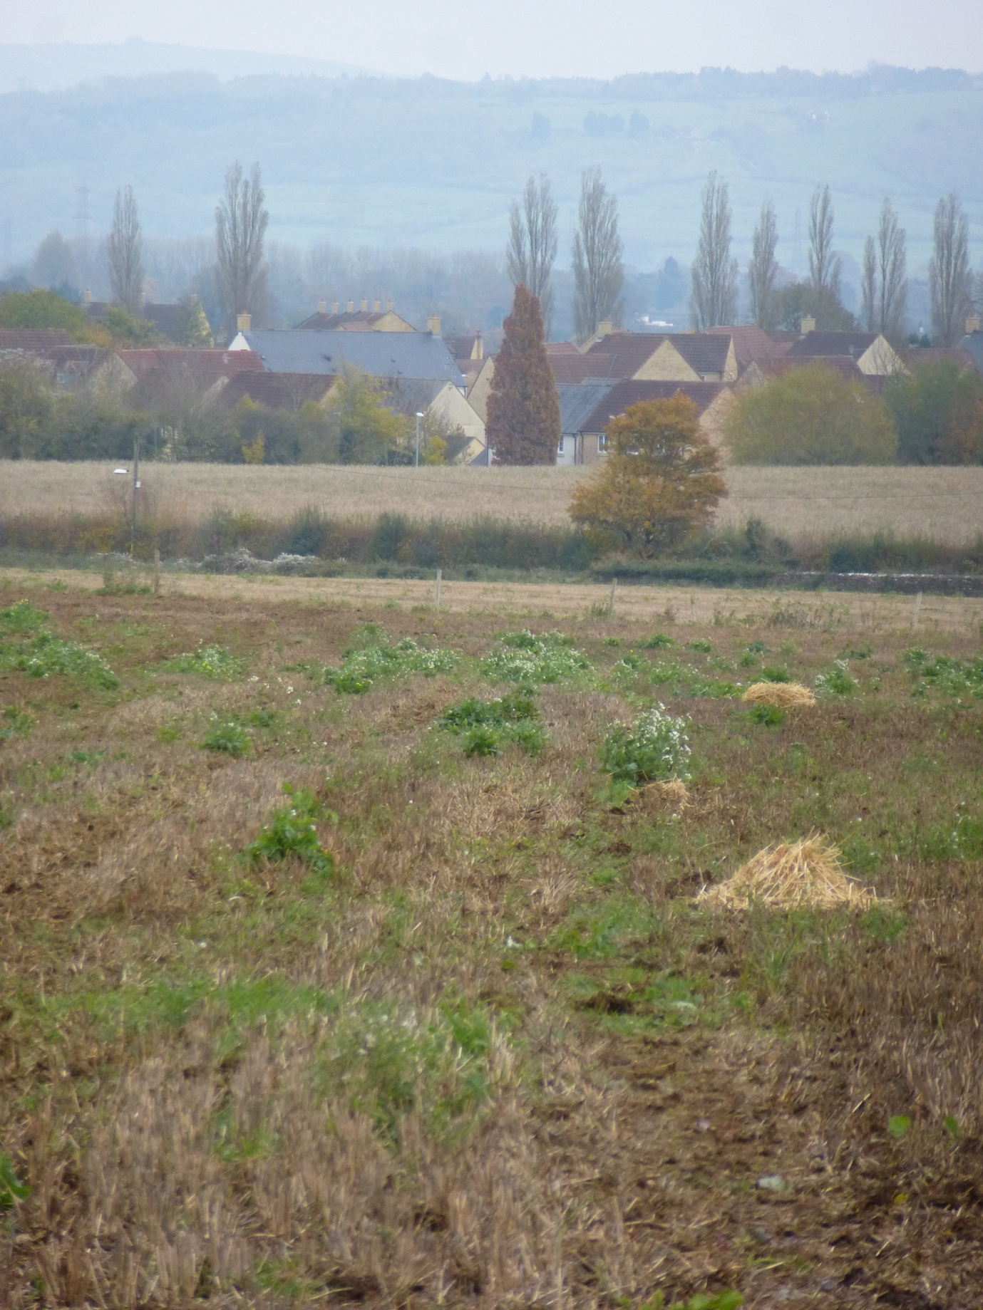

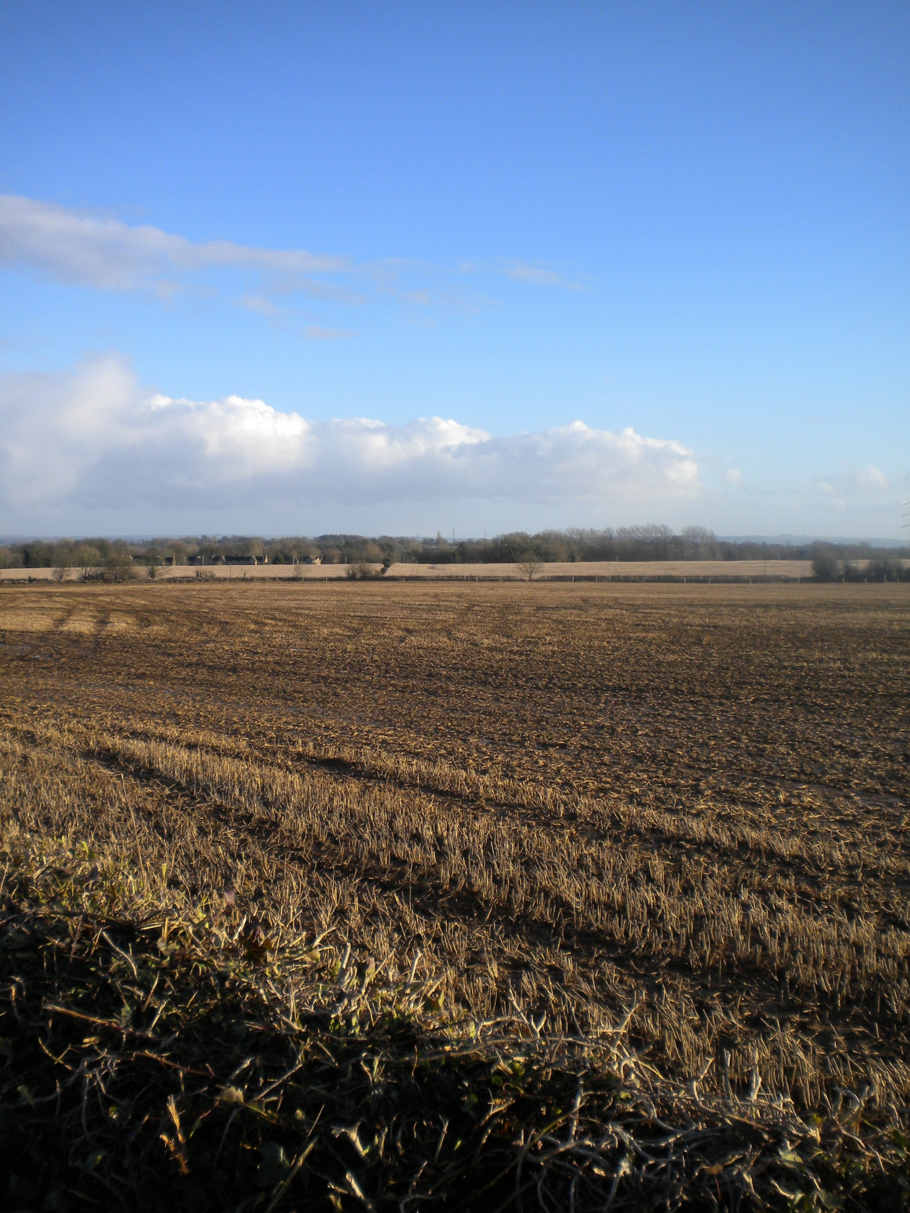

iii. The third and fourth views below, equivalents of which are not provided by Pearson, show the ‘enduring’ scenes for the walker a) looking from Park Lane in a westerly direction to the woodland at Rudloe and b) again from Park Lane looking in a northerly direction to the field twixt Copenace and Rudloe Firs. The impact of development here will be the total loss of these fine views and a loss of a ‘sense of place’ (to repeat the developer’s clichéd prose) in the countryside.
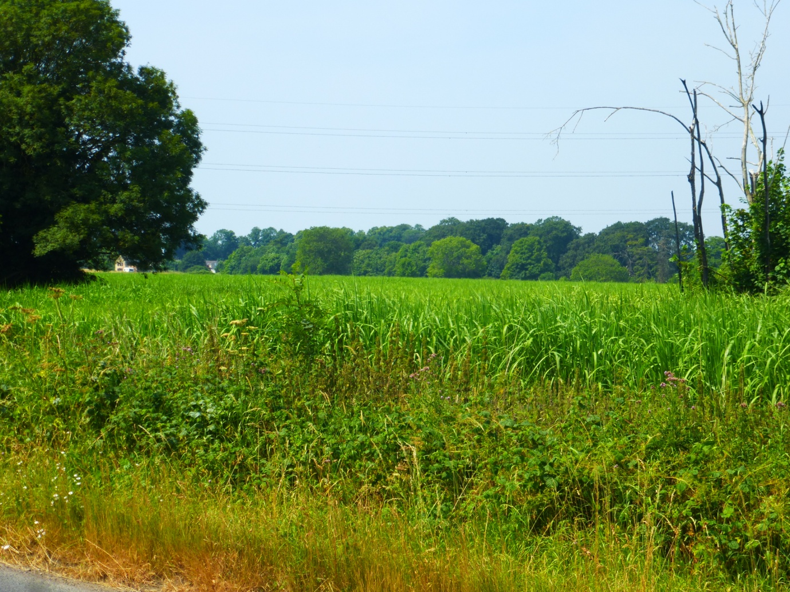

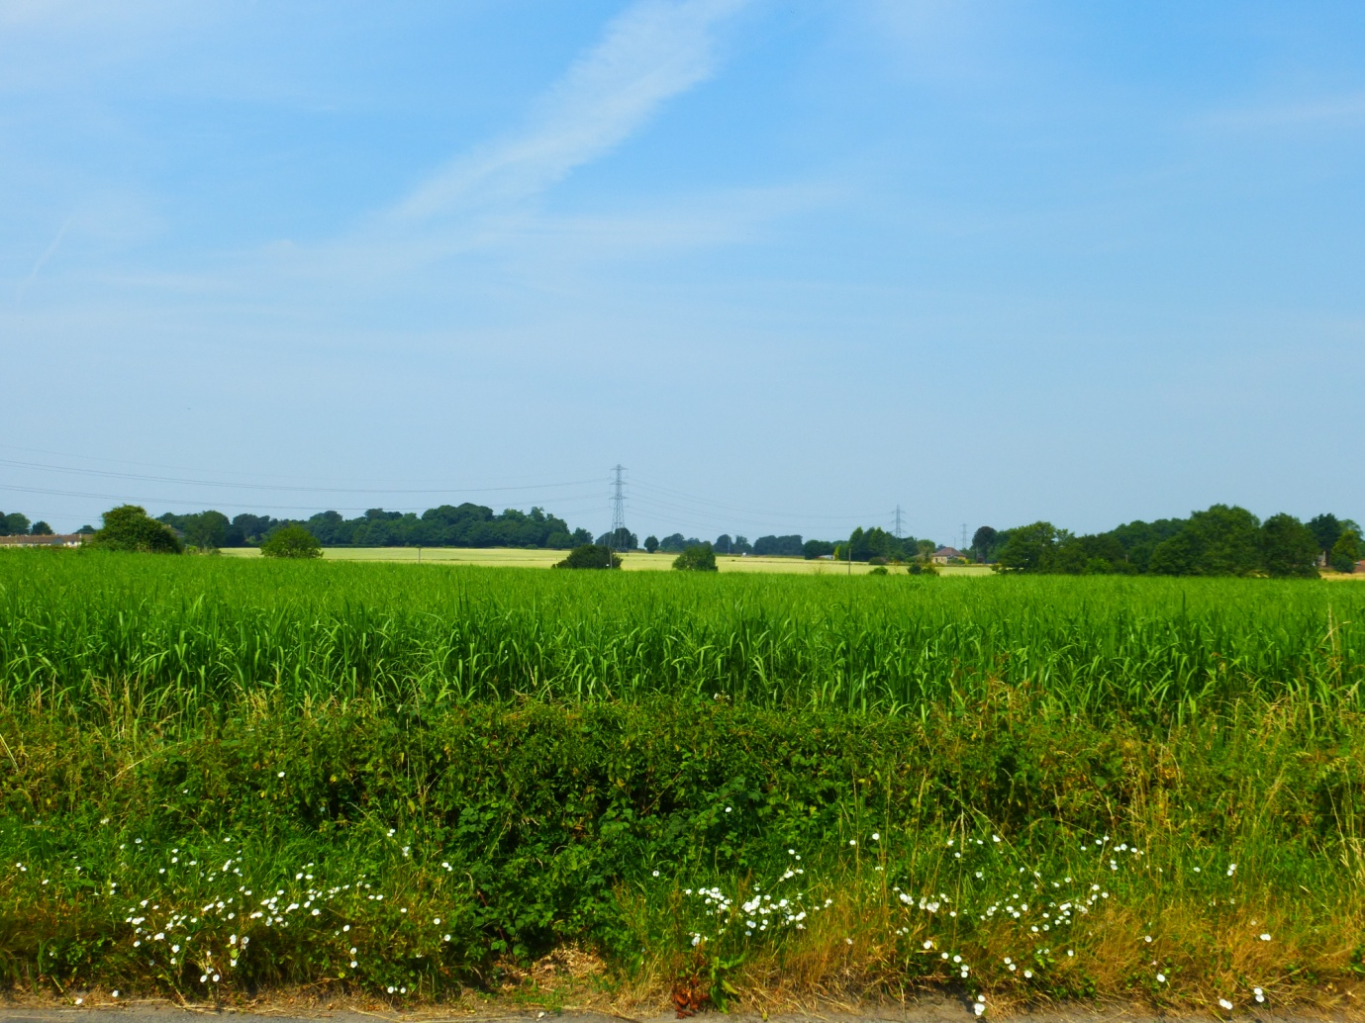
iv. Section 10.4 in ‘Summary and Conclusions’ states: “the proposals are considered to have a minor adverse effect on the local landscape character and a minor adverse visual effect”. I contend that this is not the case. They will have a significant visual impact and, more importantly (as stated above), will obliterate the ‘strategic gap’ between Corsham/Pickwick and Rudloe/Hawthorn.

d. The Planning Statement dated April 2014 by G.L. Hearn

i. Section 3.9 states: “GL Hearn have been in discussions with NHS England about the delivery of medical services in Corsham and discussions are ongoing with local GPs regarding the provision of a facility on the site should demand for new premises exist”. Interesting that the provision of medical services in Corsham is apparently being engineered not by the NHS or local GPs or Wilts County Council through strategies and plans based on community requirements but by a planning consultancy. Is this what the future holds – our health services being contrived and manipulated through the likes of messrs Hannick, Gladman and Redcliffe and their speculative developments?
ii. Section 3.10 and I despair. This says: “Comments were sought on use of the land to the east of the application site, which is included in Redcliffe Homes’ option agreement, but is not required for residential development.” This should read: “land to the west”. And this is the Planning Statement!
iii. Worrying too that section 3.11 includes the following: “At the time of writing a clear response from Council Policy Officers has not been received. However, since the meeting, it is noted that Planning Policy provided a positive response to the neighbouring Land South of Bradford Road, Rudloe scheme, which gained approval in March 2014”. So rather than the approved Hannick development being a sop that could be used as an argument against further speculative development (as imagined by Corsham councillor Whalley at the 13/05724/OUT North Wilts planning meeting), Hearn/Redcliffe are viewing this as a ‘foot in the door’.
iv. Section 4 devotes 23 paragraphs to the convolutions of the Local Plan and Core Strategy – here we find the hangman arguing for capital punishment. The housing requirement figures therein are fictions, which having been repeated by enough knaves, take on the semblance of truth. Danny Dorling’s (the Halford Mackinder Professor in Geography at Oxford University) recent (2014) book All that is Solid (subtitle: The Great Housing Disaster) gives the lie to the contrived housing requirement figures. On page 99, for example, he says: “Most of these advocates of house building programmes tend to say little about the way existing housing stock is underused – and very little about stock that isn’t used at all”. There is nothing that can be done at this late stage about the big picture however so let’s look, in the next para. (as this one is getting a little large), at the local situation.
v. The Wiltshire Housing Land Supply Statement (HLSS) is dated April 2014 (so up-to-date) not February 2014 as stated in para. 4.19 of Hearn’s Planning Statement (perhaps Hearn was referring to an interim document). Hearn uses a figure of “309 dwellings required for Corsham Town over the remaining plan period (to 2026)” taken from the HLSS. However, the HLSS whilst up-to-date is inaccurate. It does not include the 88 dwellings just approved at Rudloe (13/05724/OUT) or the impending 200 homes at RAF Rudloe No 2 brownfield site (planning app. proposed by year-end through Belgrave/Framptons) or the just-completed 17 homes at Spring Tynings (there is an entry for Spring Tynings but this says “site expected to deliver within 5 years”) or the GreenSquare ‘Rudloe Renaissance’ developments (11 homes through planning apps. 14/04482/FUL and 14/04484/FUL) or the Corsham Library and Corsham Police Station sites (about 20 homes possible here). So just totting up this little list, we arrive at a figure of 336 which fulfils the plan period housing requirement. Redcliffe’s speculation is neither welcome nor required.

e. The Transport Assessment dated April 2014 by FMW Consultancy
i. Section 3 of this document is titled ‘Accessibility by Sustainable Modes of Transport’ which, apparently, means walking, cycling and public transport. Paragraphs 3.5 and 3.6 then describe the Bradford Road and Park Lane footways/cycleway which give access to Corsham and Rudloe. However, what neither of these paras mentions is that these footways and the cycleway are on the opposite sides of the respective roads from the proposed development. As stated elsewhere, this means that every ‘sustainable’ journey starts and/or ends with the crossing of one or other of these busy roads. I contend that this state of affairs is not sustainable.

ii. Paragraph 3.10 then summarises this situation as follows: “In summary, the land at Bradford Road site can be considered to be readily accessible on foot from all residential areas of Corsham, with good quality footway links from the site into the town centre, to the local schools and to other nearby facilities”. This is also reiterated in para. 8.4 ‘Conclusions’ which states: “The proposed residential site is considered to be in a sustainable location being situated within an easy walking and cycling distance of a good range of services”. These statements are patently untrue - the development site is an ‘island’, isolated from the walking and cycling routes.

iii. Paragraphs 3.18 onwards describe public transport accessibility. Once again, what is not stated is the requirement to cross the busy Bradford Road three times for every journey undertaken. For example, crossing on foot to the north side of Bradford Road would be required for an eastbound journey then, on the return, two crossings would be required, once from the bus stop over to the north side (to the footpath) then back again to the development. Westbound journeys would see the reverse of this situation.

iv. Paragraphs 3.19, 3.20 and 3.21 (and 8.4 Conclusions) are incorrect. Bradford Road is not served by three services, but by two – the 231 and X31. The 10E service has been discontinued. There is no circular bus service (ref para. 3.21) serving Bradford Road.

v. One-hundred-and-seventeen paragraphs along with twenty tables then proceed to tell us that “there are no significant transport or traffic impact issues associated with the potential residential development of the site” (para. 8.5 ‘Conclusions’) when local people know full well that there are already significant traffic problems in this area. This plethora of data clouds the de facto situation. Locals can and have given examples of the existing jams at peak times. Just last night (28th May), I was sat in a 1.1km tailback on the A4 from the Cross Keys junction beyond the Hartham Lane junction at around 16:45. This is the real situation; further development will clearly exacerbate it notwithstanding 117 paragraphs telling us it won’t!

4. I could continue but I am running out of steam here and further wordage would probably be counter-productive. I urge Wiltshire planners to reject this speculative, greenfield, outline planning application.

Paul Turner
29 Springfield Close
Rudloe

29th May 2014

